*Service Required  服务要求 | Regular (Standard Pricing)常规 Urgent (40% Surcharge)加急 Emergency (100% Surcharge)特急  (7 Working days) (3 Working Days) (1-2 Working Days)
Quotation Request  提供报价 | Please tick the box as “X” if required quotation before testing. (Takes up to 3 working days) 如果要求测试前提供报价请在前面的  方框里打“X” (需時约3個工作日) <Testing only starts upon confirmation to accept the quotation客人确认报价后,实验室才开始检测>
Retest Reference | Retest Report No. (重测，请注明上份报告号):
Sample Return 退样 | If Self Collect Tested Samples is require please contact Customer Service representative within 2 weeks after report has been issued. 如果样品需要退回，请在收到报告后两周之内与我们联系。 |  | Express return pay by consignee (到付)

Applicant Information 申请人信息: ★Please type in ENGLISH & BLOCK LETTERS请用英文和大写字母填写 ★
*Company公司:
*Address英文地址 :
*Contact person 联系人 |  | *Tel NO.电话: |  | Fax No.传真： | *E-mail电邮:
*中文公司名称:
*中文地址 :
*Billing Information付款资料Please provide detailed contact information if billing is different from applicant (如付款人与申请人不同,请提供详细资料)
Billing Company 付款公司： |  |  | Contact Person联系人： |  |  | Tel NO.电话:
Address 地址 ： |  |  | E-mail电邮： |  |  | Fax No.传真:
 |  |  | Report Copies to (Fax No./Email /Address)报告抄送至：
中文公司名称： |  |  | Report Attention (If different from Contact Person):
中文地址 ： |  |  | (如果和联系人不同，请注明报告接收人)
NOTE注意: ***Hardcopy along with invoice will be sent to whomever bill for this report正本报告和发票将寄给报告付款方 ***
Payment Currency/Method 付款币种或方法： HKD港币 and USD美金 (only applicable for billing using oversea address仅适用于中国大陆以外公司)
RMB currency is use for all billing using Mainland China address 如付款方为中国大陆的客户将以人民币结算
Sample Information 样品资料: (须用英文填写)
Client Name/End Buyer:  请注明客户的名字/最终买家 |  |  |  |  |  | Intend Market： Adult Products 成人产品 Children Products儿童产品  SpecificAge Grade：Determined By BVSZ由BVSZ檢定  Specify Age指定测试年龄:
*Sample Description (样品描述)：
Country of Origin (原产国)： |  |  |  |  |  | Country of Destination(目的国)：
Sample Quantity (样品数)： |  |  |  |  |  | Manufacturer (制造工厂)：
Model #(型号)： |  |  | Style#： |  |  | SKU #: |  |  | PO # (定单号)：
DPCI#： |  |  | Item#： |  |  | Color (颜色)： |  |  | Shipment Date (出货日期)：
*Test Requested 测试要求 Please click the appropriate box or write down the test requirement请在相应的方框内选择测试要求，或写下具体的测试要求
(Some test may not have either 24hrs or Urgent sevice available, please kindly check with our Customer Service representative)
Furniture Test  Chair:  EN 12520:2010  BS 4875-1:2007 Test Level  EN 1022:2005  EN 581-2 Test Level  EN 1335-1 & 2  BIFMA X5.1: 2002  Table:  EN 12521: 2009  BS 4875-5:2009 Test Level  EN 581-1  EN 581-3 Test Level  EN 527-1:2000  EN 527-2:2002  EN 15372:2008 Test Level  Storage:  BS 4875-8  EN 14749:2005  BS 4875-7 Test Level |  |  |  |  | Analytical Test  Azo Dyes EC No.1907/2006  Cadmium content EC No.1907/2006  Formaldehyde release for wood EN 717-1  Formaldehyde release for wood EN 120  Formaldehyde test for leather EN 17226-3  Dimethyl fumarate (DMF)  Total Lead In Surface Coating表面涂层含铅量  CPSIA 90ppm for under age 12 (12岁以下的儿童产品) or  Adult Item(成人产品) ppm  Composite 有混色 Individual 无混色  Total Lead content in substrate 基材含铅量  CPSIA 100ppm for under age 12 (12岁以下的儿童产品) or  Adult Item(成人产品) ppm  Composite 有混色 Individual 无混色  Phthalate test 邻苯二甲酸盐含量:  6P (BBP,DBP,DEHP,DINP,DIDP,DNOP) under CPSIA 2008  3P (BBP, DBP, DEHP) under CPSIA 2008  Composite有混色 Individual无混色  Others其它：  Please select which part of material require for test:  Accessible 可接触 Inaccessible不可接触 Both两者 |  | REACH SVHC Test  138 SVHC  144 SVHC  Others:
Other Test

Flammability test 燃烧测试
TB117 (Foam海绵/ Fabric布/ Leather皮革/ Floss丝棉)
BS 5852
Others其它:

Transit test 包装运输测试
（Atmospheric conditioning: Yes No）
ISTA 1A ISTA 3A
With over-packaged carton Without over-packaged carton
Others其它: .

Resistance to corrosion 盐雾测试
ASTM B117 ISO 9227
Please specify testing time:
1% salt spray (Modified method)
5% salt spray
Other Test Requirement 除上述外如有其它测试要求，请注明 (如有必要，可以用附页追加）：
Protocol (Please specify the protocol NO.) 请填写具体的测试草案号码: Full tests全套测试 Partial tests部分测试Provide attachment if any请用附件追加说明
General Conformity Certificate / Children's Products Certificate
送样板时，请确保附上第二页，谢谢。
*Date日期 |  |  |  | *Authorized Signature and Company Chop 授权人签署和公司盖章：
NPD field = COMPONENT RAW MATERIALS

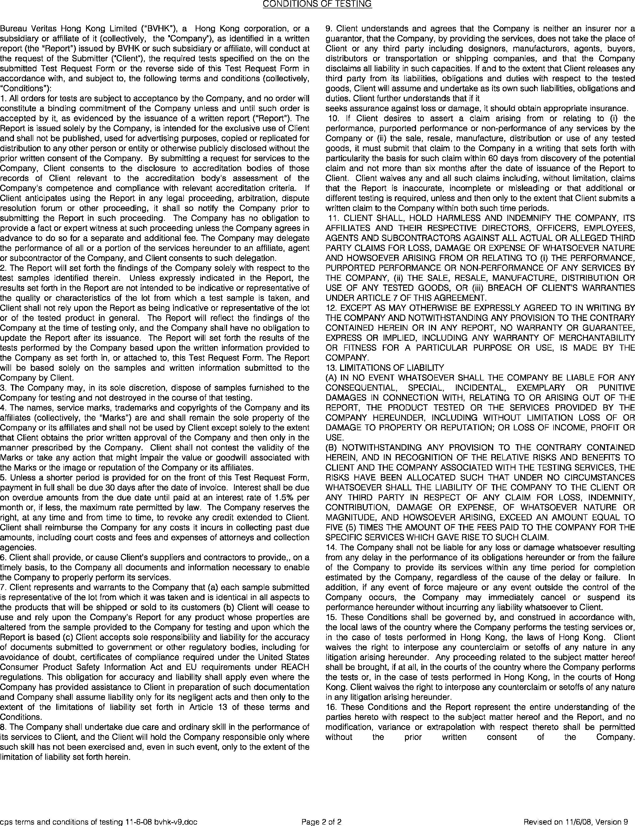

SUBMITTING PROCEDURE

SUBMITTING PROCEDURE

- Fill in proper Test Request Form based on different sections as enclosed (for local Client) and send to our office together with testing samples. For contract Client, please download specific Test Request Form from our web site (www.cps.bureauveritas.com) or call (86)755 8600 0151 for details.

- Test report copy will be sent to Client by email/fax when completed.

- Original Test Report and Invoice will be mailed to the Client on timely base. Tested and left over samples could be returned on request with prior notice on the Test Request Form (Additional charge for courier may be applied).

- Remarks:
- Office hours are from 9:00 am to 18:00 pm on Monday to Friday and 9:00 am to 12:00 pm on Saturday (Saturday is not considered as working day).

- Regular Services usually take 7 working days after receipt of samples. (Longer turnaround time may be required dependent on test property).

- Test results for Express Services are usually available within 3 working days after receipt of samples and a surcharge of 40% will be added to the list prices. (Longer turnaround time may be required dependent on test property).

- Test results for Emergency Services usually take 1-2 working days and are available for some tests at surcharge of 100%. (Longer turnaround time may be required dependent on test property).

- Working day calculation will be as follow:
Sample arrived laboratory Sample log-in
- From 9:00 am to 12:00 pm count same working day
- After 12:00 pm count next working day
- For submissions use our pick-up service, same working day log-in will be provided only when the order call is requested before 4:00pm of previous day.

- When an application form requests several test requirements in different speeds of service, the final test report will not be issued until all tests are completed.

- Daily pick-up and delivery service are available for small sized samples in specific areas only (Call (86)755 8600 0151 ext. 101 for more details on this service)

- Discount is available on a contract basis, subject to certain minimum volumes.

- Additional tests and prices not indicated in the price list are available on request.

- Telephone, Telex, Cable, Facsimile and any postage costs incurred by BUREAU VERITAS SHENZHEN CO., LTD. will be charged to the client’s account.

- Testing fees and any additional costs can be paid in the following way:
- (For RMB)BUREAU VERITAS SHENZHEN CO., LTD. credit account please call (86) 755 3304 6555 and (For USD or HKD)BV HK Ltd. please call (852) 2331-0888)- Payment must be made in accordance with the 30 days net terms.

- There is minimum charge of RMB200 per report.

- Tested samples not destroyed, maybe reclaimed after testing if prior notice is given on the application form and generally, only one sample will be retained for a maximum period of 30 days. ISTA transit test samples are retained for a maximum of 14 days.

- Our Cancellation Policy is available on request. If the cancellation of tests is made after the tests have been started, the fees of conducted tests may still be charged.

- Conditions and fees are subject to change without prior notice.

